

**Graphics Programming**

**Software Development for Computer Games**

**Bill Mitchell**

**S1621554**

*I confirm that the code contained in this file (other than that provided or authorised) is all my own work and has not been submitted elsewhere in fulfilment of this or any other award.*

*Bill Mitchell.*

**Contents**

1. Gooch Shader 3

1.1 Main Game 3

1.2 shaderGooch.vert 3

1.2.1 Variables 3

1.2.2 main() 4

1.3 shaderGooch.frag 4

1.3.1 Variables 4

1.3.2 main() 5

2. References 7

2.1 Model 7

# 1. Gooch Shader

## 1.1 Main Game

*Figure 1. drawGame() within mainGame()*

The shader is initiated in the in the DrawGame() function of MainGame.cpp by calling the init() function of the shader script and passing in the location in the file of the shaderGooch fragment and vertex files. The shader is then bound, and the Uniforms are then passed in by making use of the SetUniform function within MainGame.cpp and the shader is passed in along with the name of the Uniform within the shader and the value of which that uniform should be set.

## 1.2 shaderGooch.vert

### 1.2.1 Variables

*Figure 2. Variables within the vertex shader*

The variables within shader.vert are; two Vector3’s, VertexPosition and VertexNormal, which are bound to a location when the shader is initialised and called from the location. Two Matrix4’s, Projection (which holds the projection matrix) and ModelViewMatrix, a Matrix3, NormalMatrix, and a Vector3 lightPos (which holds the position of the light) are passed into the shader as a uniform from MainGame as discussed earlier. There are also three variables set as out, which allow the variables to be passed to the fragment shader, or other files within the shader. These variables are NormDot, a float, ReflectVec and ViewVec, both Vector3’s.

### 1.2.2 main() A screenshot of a computer screen

*Figure 3. main() within the vertex shader*

The main function within the vertex shader is used to set the values that are to be passed out to the fragment shader. This is done by first creating a local vector3 called Pos that is equal to a vector3 of the ModelViewProjectionMatrix multiplied by the VertexPosition which gets the position of the vertex.

Then a Vector3 called Normal is set to the NormalMatrix multiplied by the VertexNormal and normalized to give the normalised version of the Normal vector.

The final Vector3 to be created is light and it is the lightPos minus the Position of the vector and normalized to get whether the light is affecting the vector.

The View Vector is then set to the negative of the Pos vector and normalized. The Reflect Vector is set using the reflect function passing in the negative of the light vector and the Normal variables and then this is normalized. Finally, the NormDot variable is set which is the dot product of the Normal and light variables. These three variables are passed to the fragment shader to be used there.

gl_Position is then set to the ModelViewProjection Matrix and multiplied by the VertexPosition which sets the position of the vertex as a Vector4 rather than as a Vector 3 set in the Pos variable.

## 1.3 shaderGooch.frag

### 1.3.1 Variables

*Figure 4. Variables within the fragment shader*

Within the fragment shader, there are three variables that are passed in from the vertex shader (and are named the same to allow for the values to be passed to the right variable). These variables hold the Dot product of the Normal and the Light vectors of vertex shader (NormDot), the reflection vector and the view vector.

The final variable, FragColor, is used to determine the colour of the fragment that should be applied.

### 1.3.2 main()

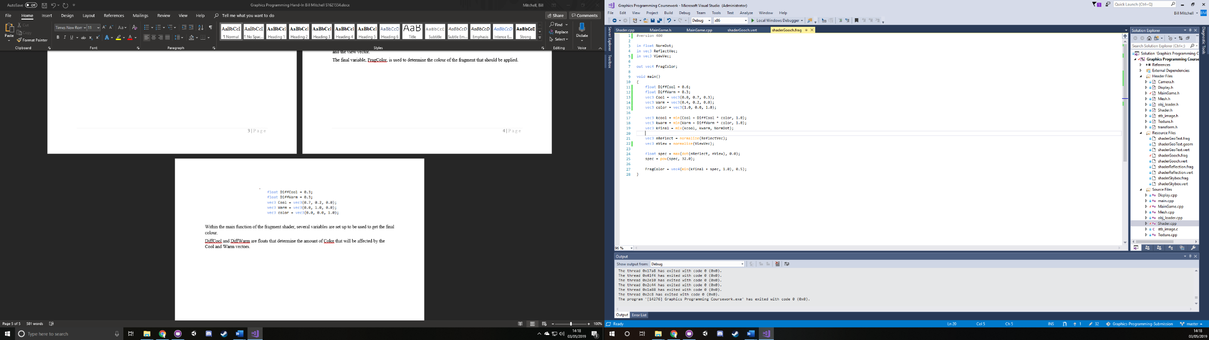 *Figure 5. Local Variables within main() of fragment shader*

Within the main function of the fragment shader, several variables are set up to be used to get the final colour.

DiffCool and DiffWarm are Floats that determine the amount of color that will be affected by the Cool and Warm vectors.

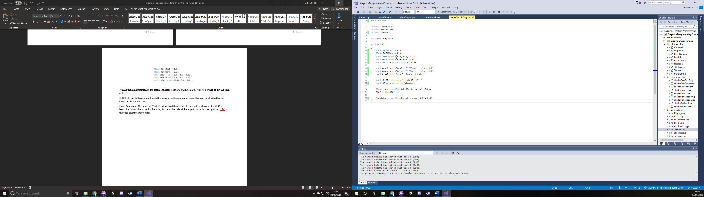Cool, Warm and Color are all Vector3’s that hold the colours to be used for the object with Cool being the colour that is hit by the light, Warm is the side of the object not hit by the light and color is the base colour of the object.

*Figure 6. Local Variables using OpenGL functions within main() of fragment shader*

The Vector3’s fcool and fwarm make use of the min() function, which returns the lowest of two values, to set the value to either the colour value of the Cool vector added with the color multiplied by the DiffCool variable, or the Warm vector and DiffWarm for fwarm, or to white.

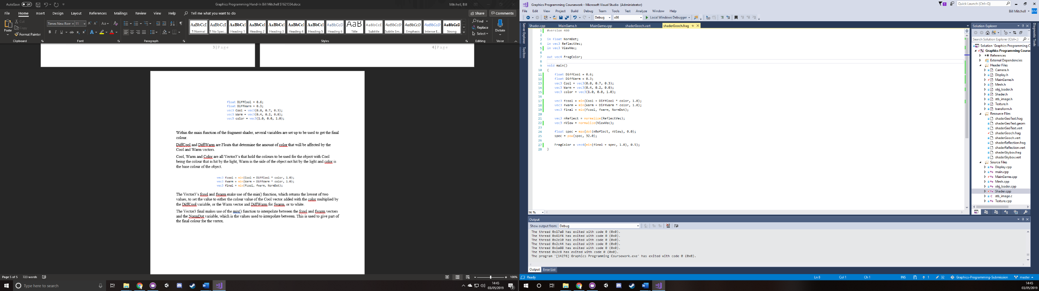The Vector3 final makes use of the mix() function to interpolate between the fcool and fwarm vectors and the NormDot variable, which is the values used to interpolate between. This is used to give part of the final colour for the vertex.

*Figure 7. Local Variables within main() of fragment shader using normalize()*

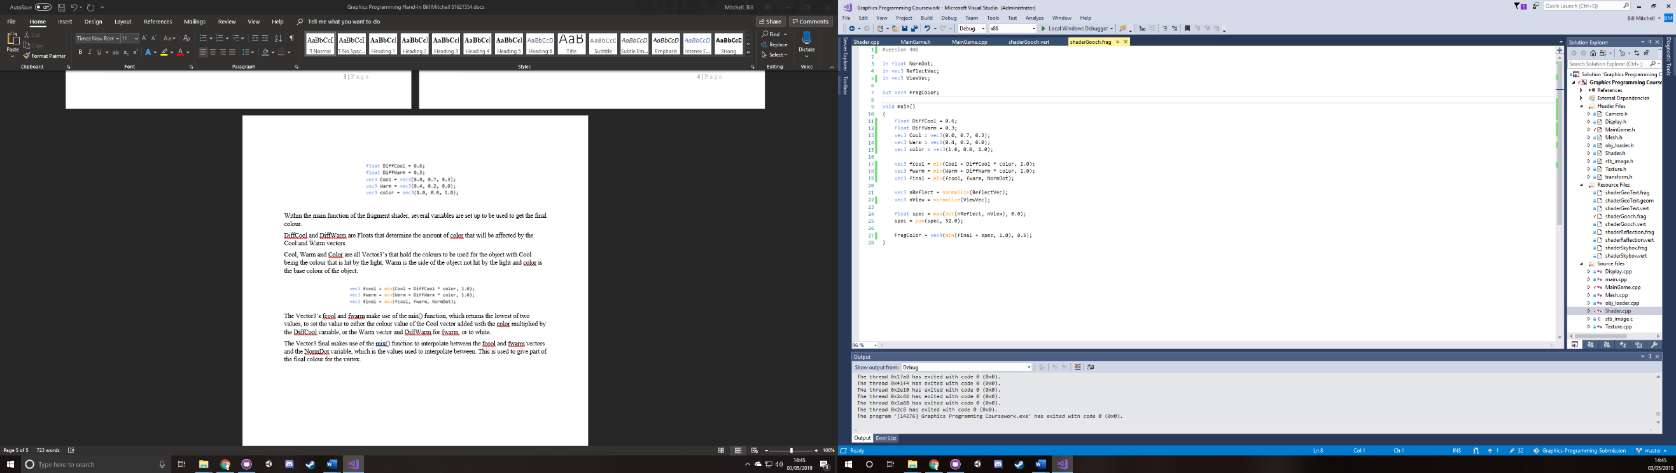A Vector3 called nReflect is created and used to store the normalised version of the passed in ReflectVec which is set by using the normalize() function and the Vector3 nView holds the normalised version of the ViewVec passed in.

*Figure 8. spec being set using OpenGL functions*

A float called spec take the nReflect and nView vectors and uses them to get the Dot product, using the dot() function, and takes the maximum values between the dot result and 0. This is done using the max() function.

The spec variable then is set to itself to the power of 32, making use of the pow() function.

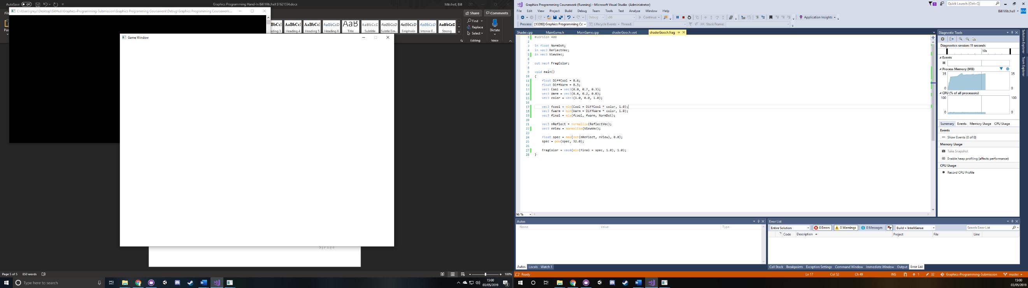 *Figure 9. FragColor*

Finally, the FragColor is set by taking the minimum value, using the min() function, between the final and spec variables added together or 1 and setting this to a Vector4 to give an RGBA variable for the vertex, with the 1.0 being the alpha and the minimum result being the RGB.

# 2. References

Benton, A (2012) Advanced Graphics. Available at:

<http://bentonian.com/teaching/AdvGraph1314/7.%20OpenGL%20and%20shaders%202.pdf> [Accessed on: 02/05/2019].

## 2.1 Model

Cylinder - <https://free3d.com/3d-model/hollow-cylinder-v1--917904.html>

Pokeball - <https://free3d.com/3d-model/pokeball-4613.html>

Hexagon – <https://free3d.com/3d-model/hexagonal-prism-v1--290091.html>